Java Collection Framework-1

INSTRUCTOR: Love Babbar

Module 1

horizontal line

# 23 November 2024

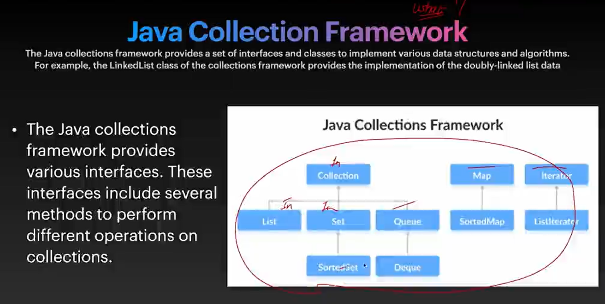

Used to utilize implementation of data structures like LL, Tree, HashMap, ArrayList

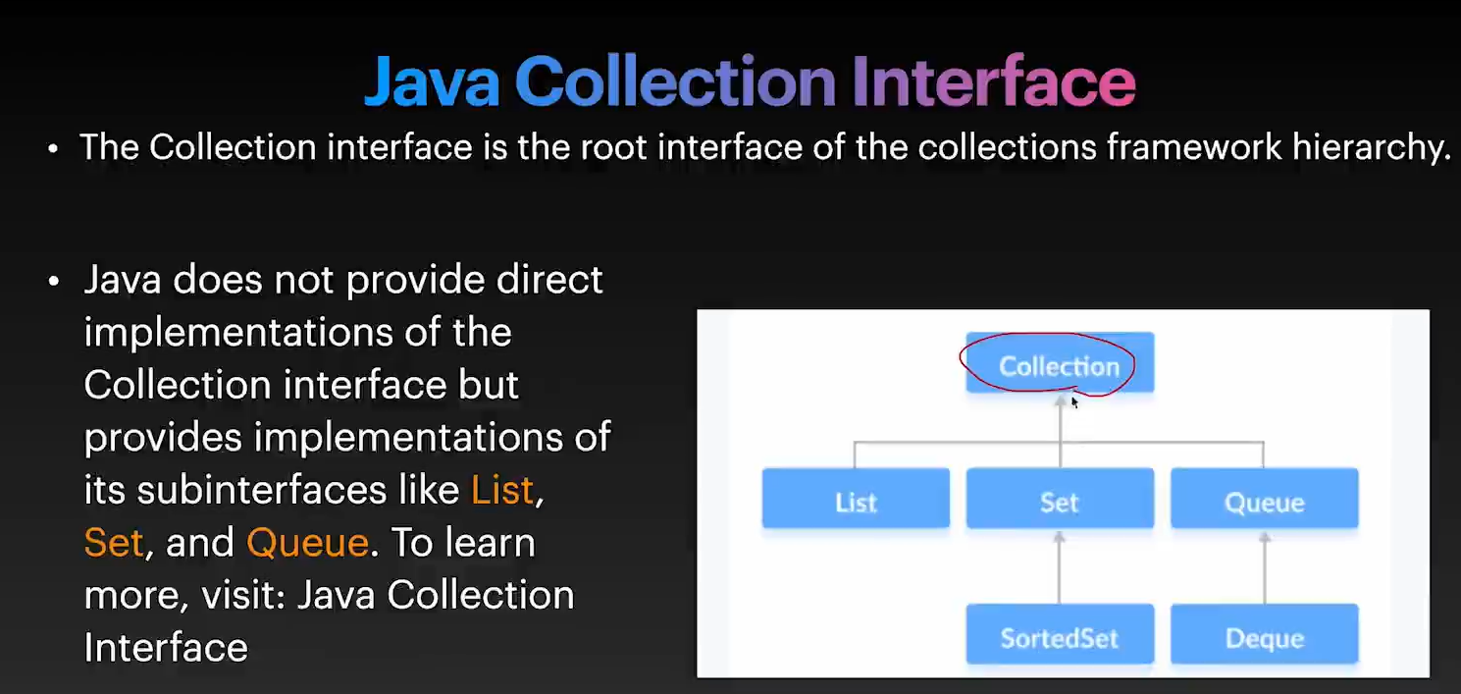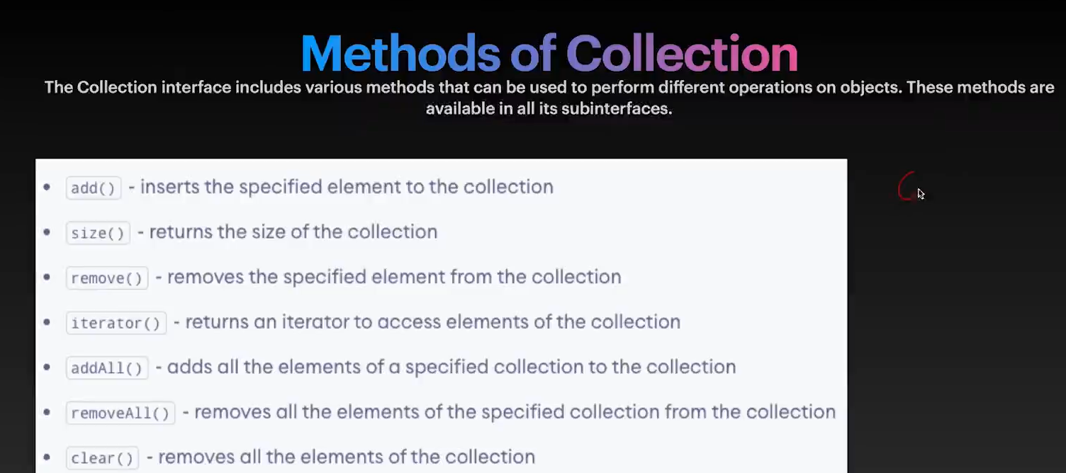

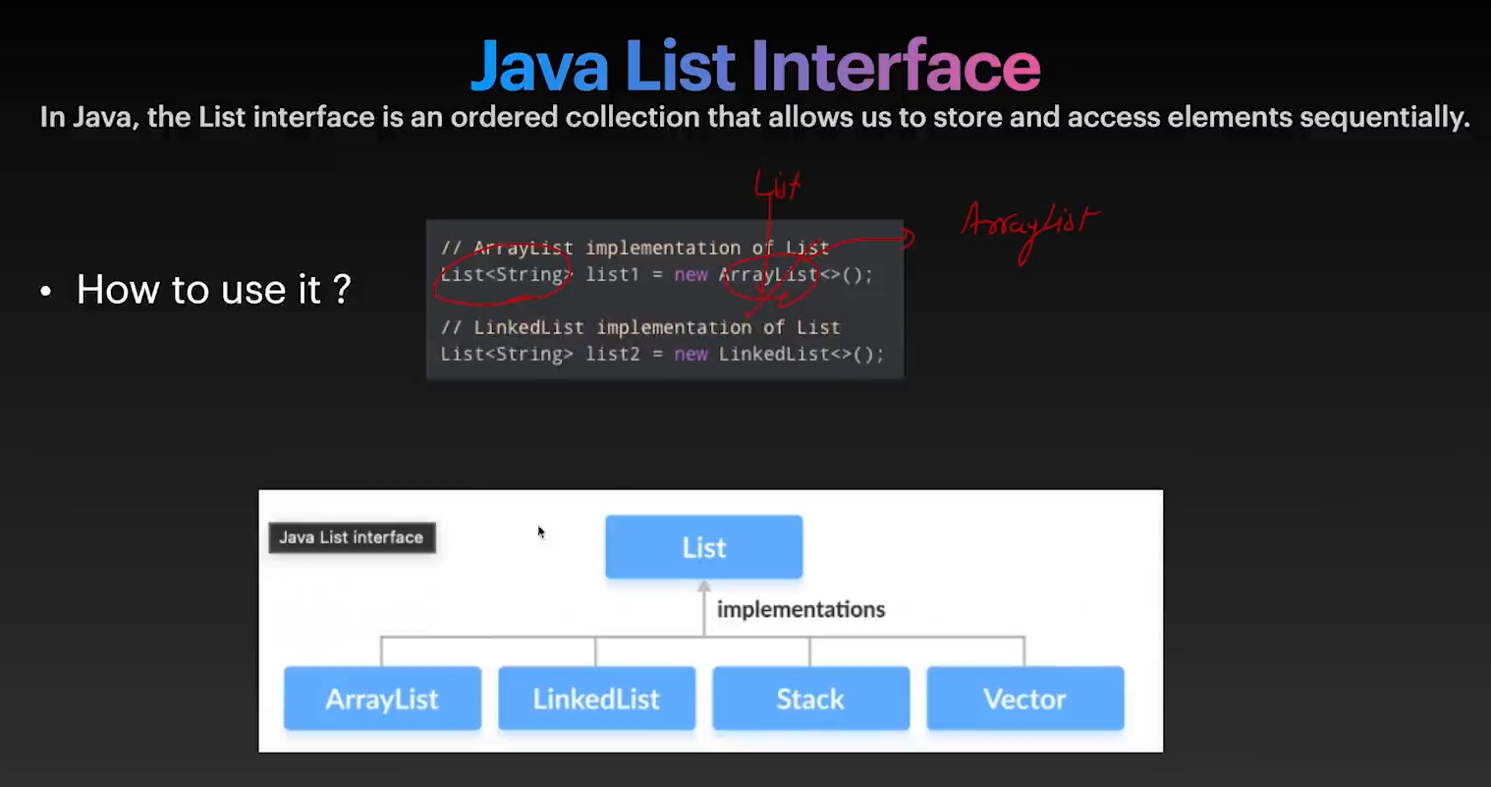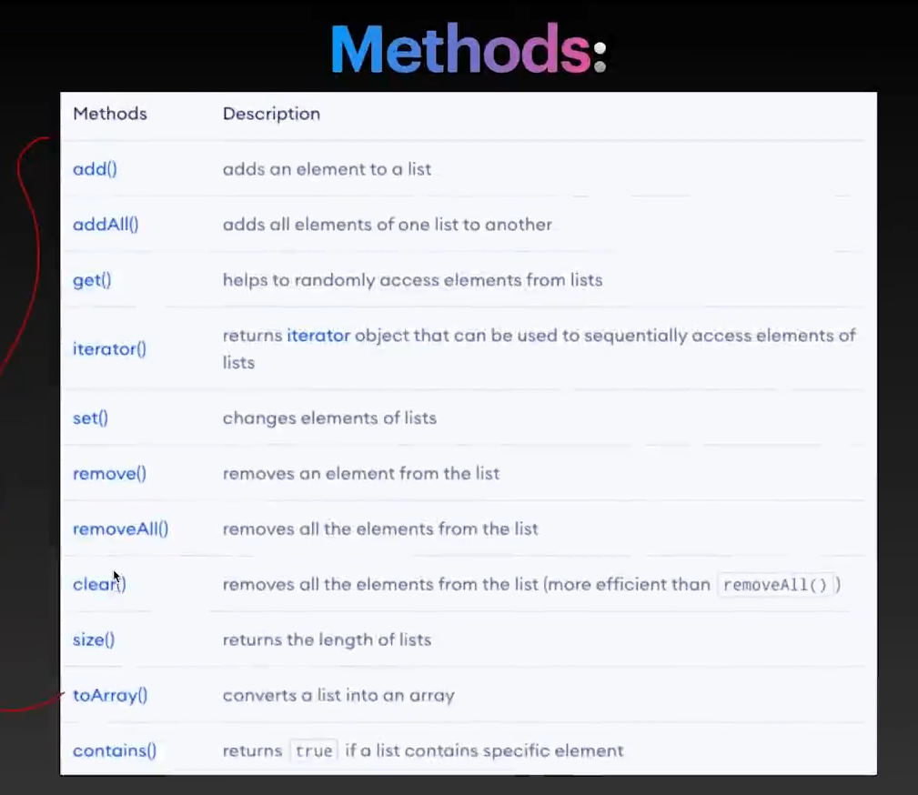

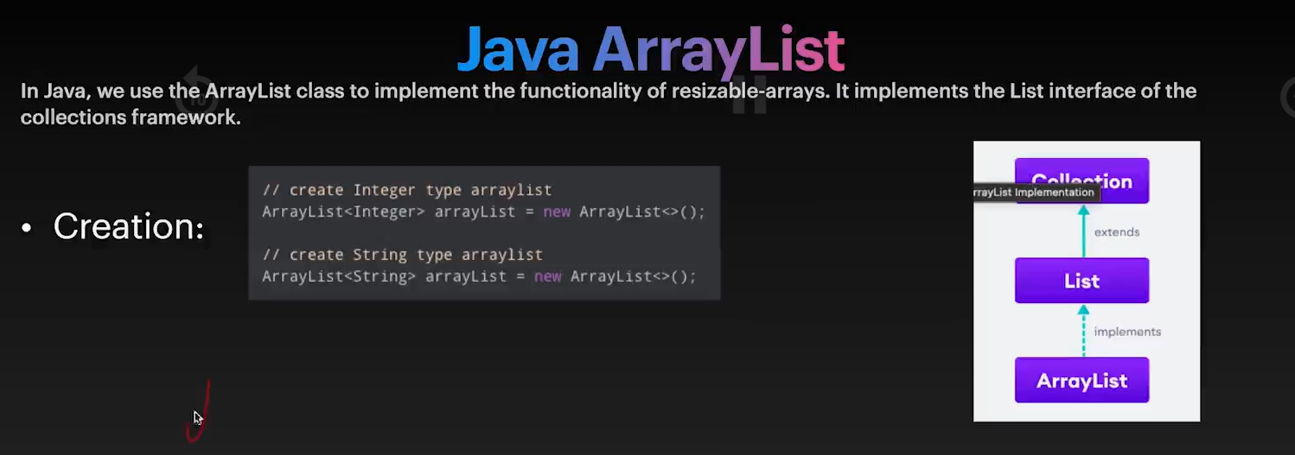

ArrayList in java == vector in cpp

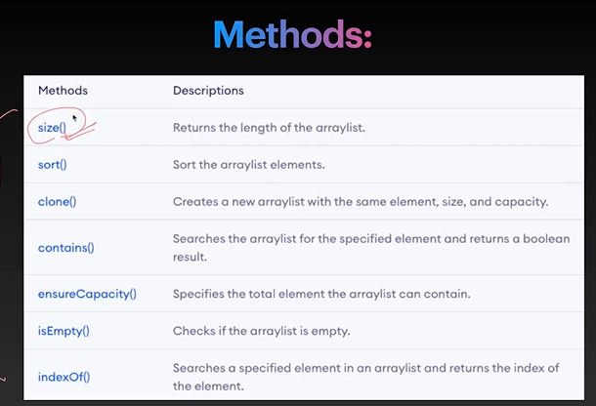

Iterator

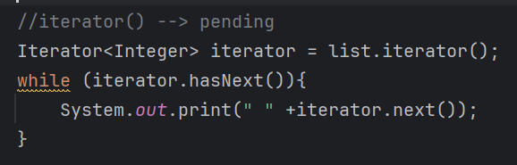

hasNext() → returns true if has next element else false

And goes to next element if next element is present

next() → returns the next element

ensureCapacity() →

1. lets say suppose we have set the threshold for array is 75%
2. So if array is full upto 75% then it will automatically create the new array of size 1.5x.
3. And copy the values of old array to new array.
4. Changes the reference to new array.

